Practical 1

Introduction of Library Management System

### Abstract

Library management system is a project which aims in developing a computerized

system to maintain all the daily work of library .This project has many features

which are generally not available in normal library management systems like

facility of user login and a facility of teachers login .It also has a facility of admin

login through which the admin can monitor the whole system .It also has facility

of an online notice board where teachers can student can put up information about

workshops or seminars being held in our colleges or nearby colleges and librarian

after proper verification from the concerned institution organizing the seminar can

add it to the notice board . It has also a facility where student after logging in their

accounts can see list of books issued and its issue date and return date and also the

students can request the librarian to add new books by filling the book request

form. The librarian after logging into his account i.e. admin account can generate

various reports such as student report , issue report, teacher report and book report

Overall this project of ours is being developed to help the students as well as staff

of library to maintain the library in the best way possible and also reduce the human

Library management system is a system which aims in developing a computerized system to maintain all the daily work of library. This system will act as a tool to transfer traditional library into digital library. This project has many features which are generally not available in general library system like facility of user login, books search on one click etc. It also has a facility of admin login through which the admin can monitor the whole system.  This system will be designed with the basic features such as librarian can add/view/update/delete books and students' details in it. It has also a facility where student after logging in their accounts can see list of books issued and its issue date and return date and also they can request the librarian to add new books by filling the book request form. The librarian after logging into his account i.e. admin account can generate various reports such as student report , issue report, teacher report and book report.

Main purpose of this system is to reduce human efforts as much as possible.

which are generally not available in normal library management systems like

facility of user login and a facility of teachers login .It also has a facility of admin

### Introduction

This project is basically updating the manual library system into an internet-based application so that the users can know the details of their account, availability of books etc. It is a multi-user version and can take care of all the fundamental functions of a Library like Cataloguing, Circulation, Accessioning and Housekeeping. It can satisfactorily cater to all the basic functions of a small library.

### Product features

#### There are three different users who will be using this product:

* Librarian who will be acting as the administrator.
* Member who will be accessing the library.
* Guest who will request for membership.

#### The features that are require for the Librarian are:

* Control the movement of books and other material and avoid losing the same.
* Search if you have a specific book in your collection based on the title, author etc.
* Print the spine labels for the book.
* Find what a specific person has borrowed from you. It offers the following modules Cataloguing, Circulation, Queries.
* Can issue a book to the student.
* Can view the list of books available in each category.
* Can take the book returned from students.
* Add books and their information of the books to the database.
* Edit the information of the existing books.
* Can check the report of the issued Books.
* Can access all the accounts of the students.

#### The features that are require for the Member are:

* Can view the different categories of books available in the library.
* Can view the List of books available in each category.
* Can own an account in the library.
* Can view the books issued to him.
* Can put a request for a new book.

### Functional Requirement

#### Librarian

* **Add Article**: New entries must be entered in database
* **Update Article**: Any changes in articles should be updated in case of update3.
* **Delete Article**: Wrong entry must be removed from system
* **Membership management**: To maintain a detailed database of the members. The system records the name, ID and password of each user. The system helps in ascertaining the track record of the member.
* **Bar-coding**: To give specific identification to each book. All books, old and new, are bar-coded on the basis of title, author, topic and date of publishing.
* **Barcode scanning**: To read the barcode easily using RFID sensors. The database is automatically updated when books are scanned while issuing or returning.
* **Search function**: to enable both the librarian and the members to search the catalog of books in the library. The search functions can be filtered to the need of each user.
* **Check out Article**: To issue any article must be checked out
* **Check In article**: After receiving any article system will renter article by Checking
* **Reserve Article**: This use case is used to reserve any book with the name of librarian, it can be pledged.
* **Set user Permission**: From this user case Librarian can give permission categorically, also enabling/disabling of user permission can be set through this use case

#### Member

* **Authentication**: User must be authenticated before accessing system
* **Search Article**: User can search any article
* **Request Article**: After successful searching member mark this book as requested article
* **Check Account**: This use case is used to check account details

### Non-Functional Requirement

#### Usability

The UI should be simple enough for everyone to understand and get the relevant information without any special training. Different languages can be provided based on the requirements.

#### Accuracy

The data stored about the books and the fines calculated should be correct, consistent, and reliable.

#### Availability

The System should be available for the duration when the library operates and must be recovered within an hour or less if it fails. The system should respond to the requests within two seconds or less.

#### Maintainability

The software should be easily maintainable and adding new features and making changes to the software must be as simple as possible. In addition to this, the software must also be portable.

Practical 2 **:** Use-Case Diagram

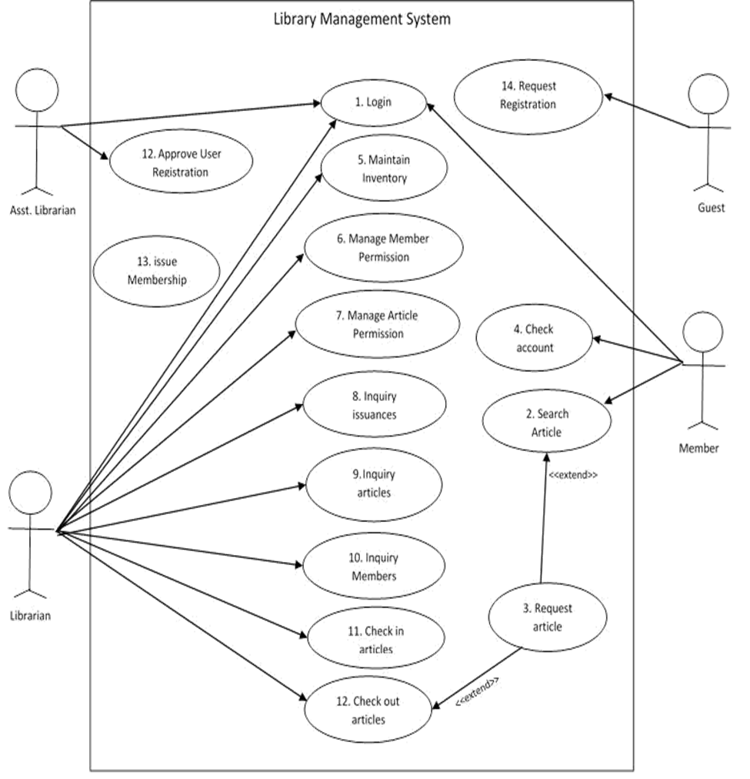

Fig. 2.1 Use case diagram of library management

### Practical 3 : 1) Activity Diagram

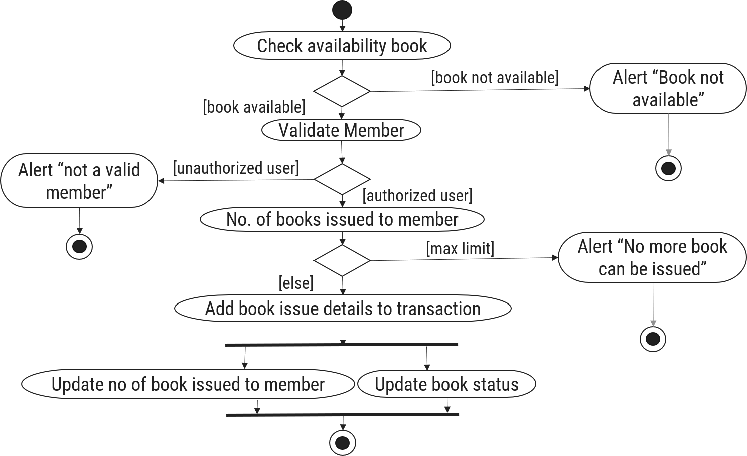

Fig. 3.1 Activity Diagram for Book Issue

### 2) Swimlane Diagram

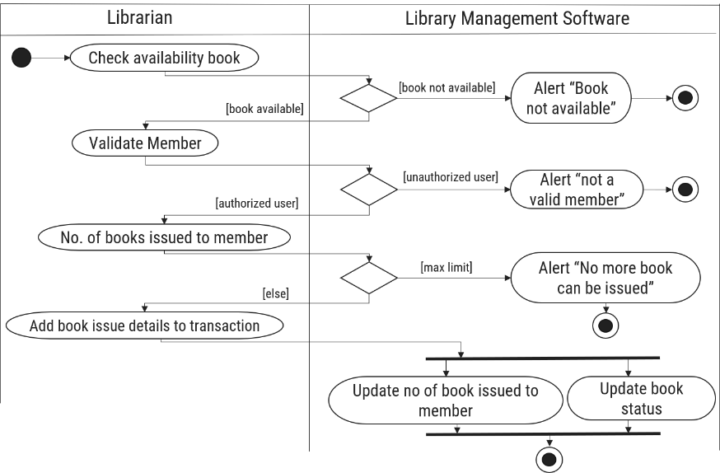

Fig. 3.2 Swimlane Diagram for Book Issue

### Practical 4 : Sequence Diagram

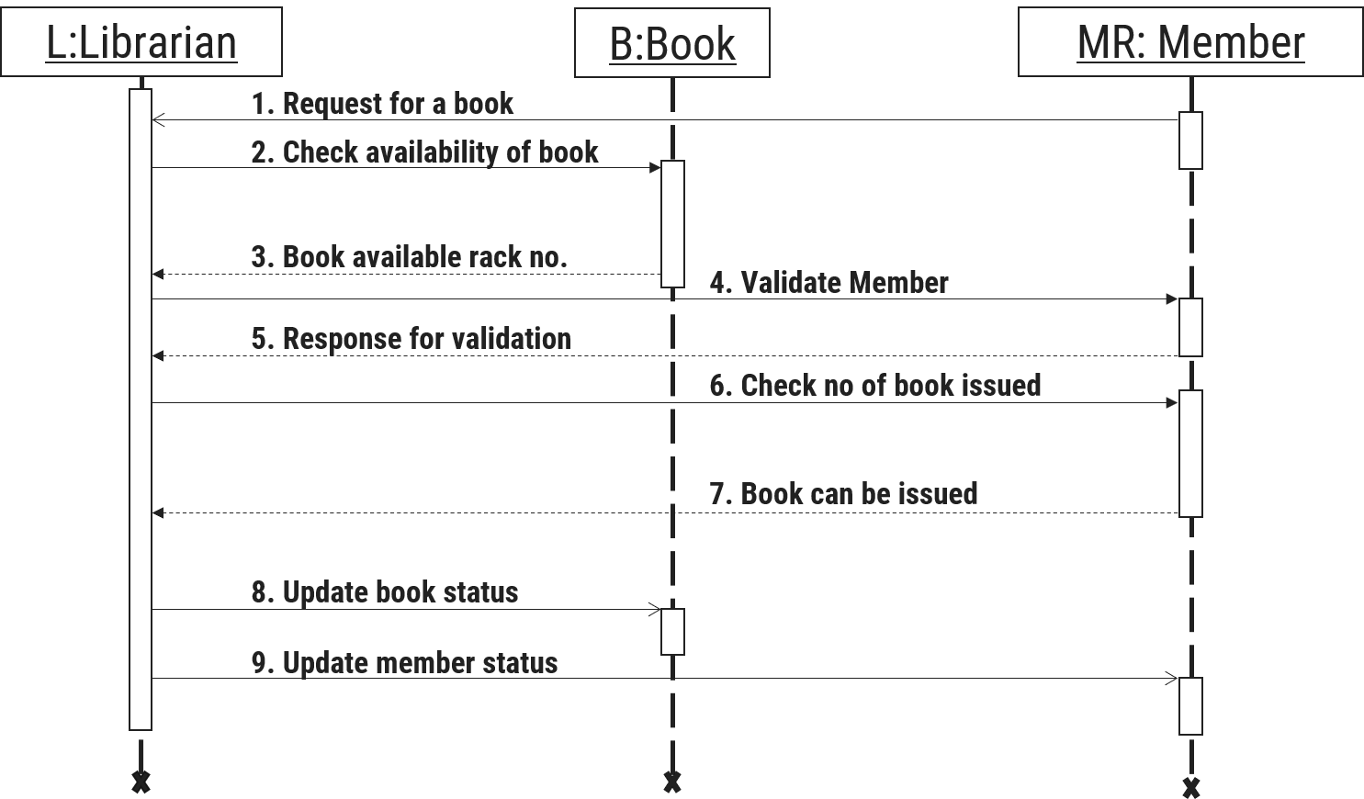

Fig. 4.1 Sequence Diagram for book issue

### Practical 5 : State Diagram

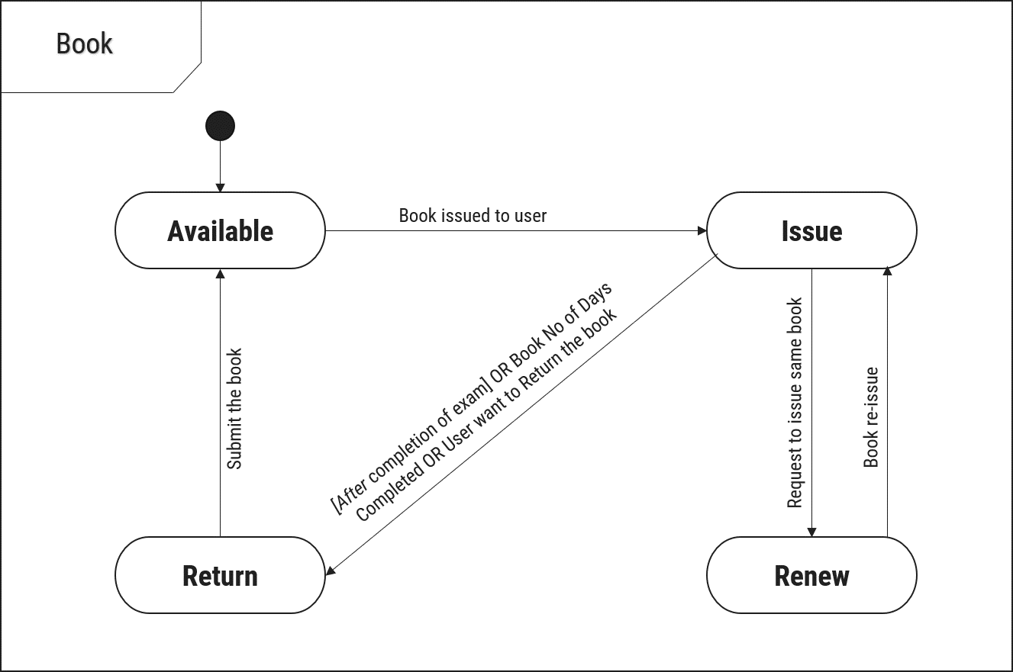

Fig. 5.1 State Diagram of Book

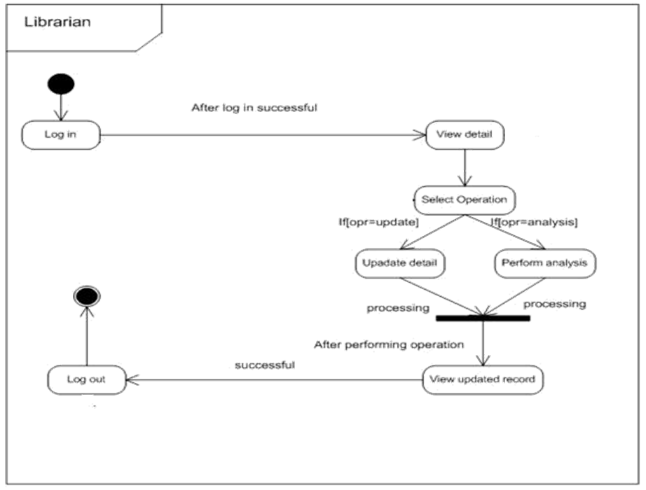

Fig. 5.2 State Diagram of Librarian

### Practical 6 : Class Diagram

### 

Fig. 4.1 Class Diagram for Library Management System

### Practical 7 : Dataflow Diagram

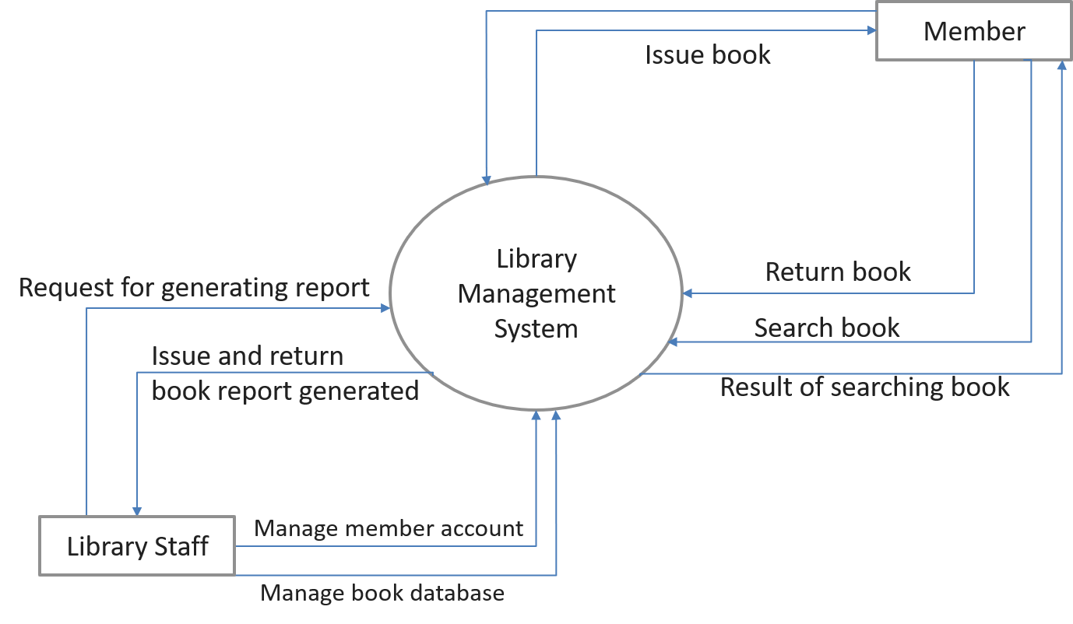**7.1 DFD level – 0 (context diagram)**

Fig. 7.1 DFD Level-0 (Context Diagram) For Library Management System

**7.2 DFD level – 1 diagram**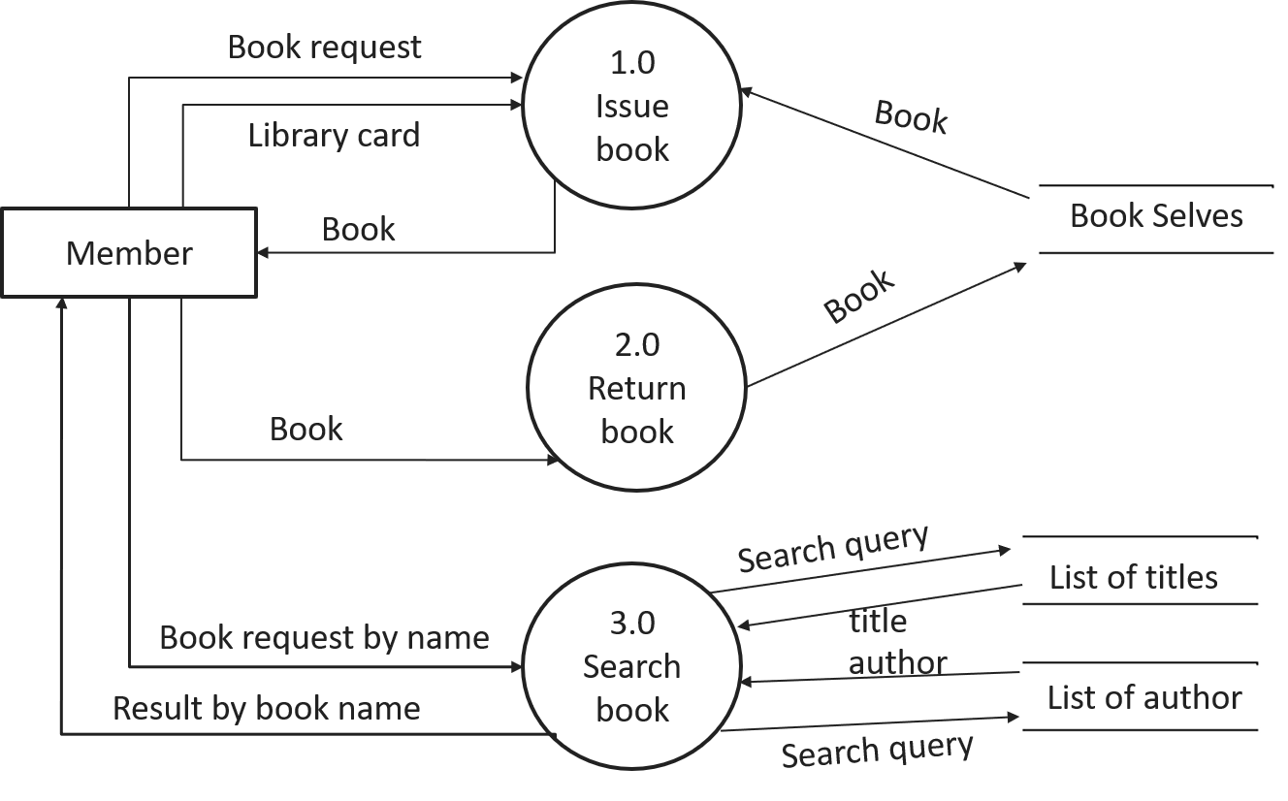

Fig. 7.2 DFD Level-1 For Library Management System

**7.3 DFD level – 2 diagram**

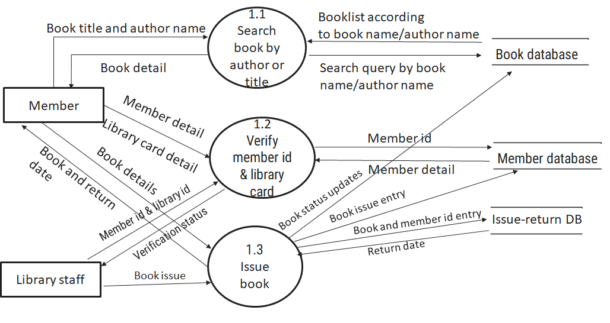

Fig. 7.3 DFD Level-2 For book issue for Library Management System

Practical 8

Prepare screens of the given project & provide detailed description of elements of each screen.

### Screen 1: Registration Form

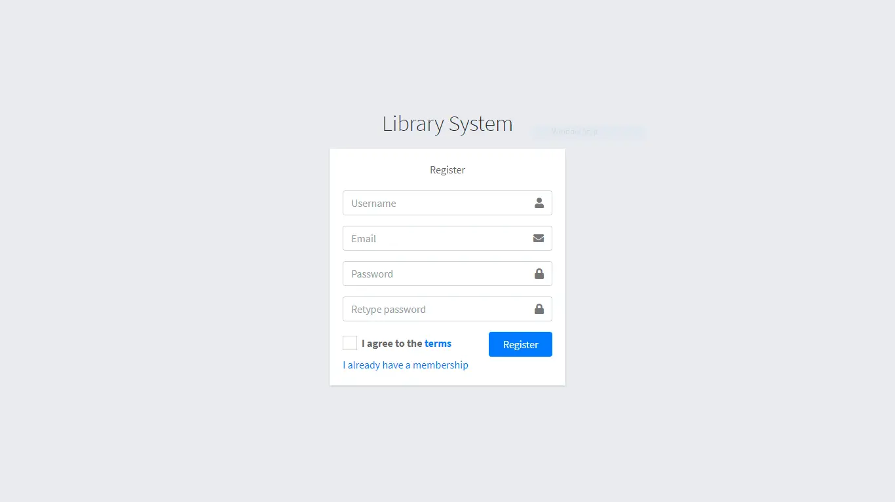

Figure 8.1 Screen-1: Registration Form

**Purpose**: This form will allow the target end-users to register in the system. To register , the following information will be encoded in the system.

Table 8.1 Screen element of Registration form

|  |  |  |
| --- | --- | --- |
| Sr. | Field Name | Description |
| 1 | Username | Username field should be editable and accept the Username. |
| 2 | Email | Email field should be editable and accept the email with proper format. |
| 3 | Password | Password field should be editable and accept the password and display as star or dot. |
| 4 | Retype password | Retype Password field should be editable and accept the password and display as star or dot. |
| 5 | I agree to the terms | Checkbox for accepting terms and condition. |
| 6 | I already have a membership | Link for navigate to login page for registered user. |
| 7 | Register | Register is a button for store the entered data into database. |

### Screen 2: Login Form

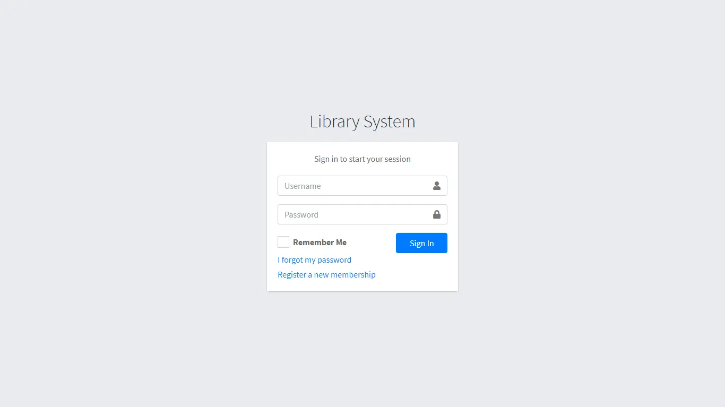

Figure 8.2 Screen-2: Login Form

**Purpose**: This form will be used by the system’s users to access records and features of the system. The users will input the correct combination of their username and password to be able to login to the system.

Table 8.2 Screen element of Login form

|  |  |  |
| --- | --- | --- |
| Sr. | Field Name | Description |
| 1 | Username | Username field should be editable and accept the Username. |
| 2 | Password | Password field should be editable and accept the password and display as star or dot. |
| 3 | Remember Me | Saving login credentials through remember me checkbox |
| 4 | I forgot my password | Link for navigate to Forgot password page for allows users to recover password. |
| 5 | Register a new membership | Link for navigate to membership registration. |
| 6 | Sign in | Login button navigates to another page even if valid login credentials. |

### Screen 3: Add Borrower Book

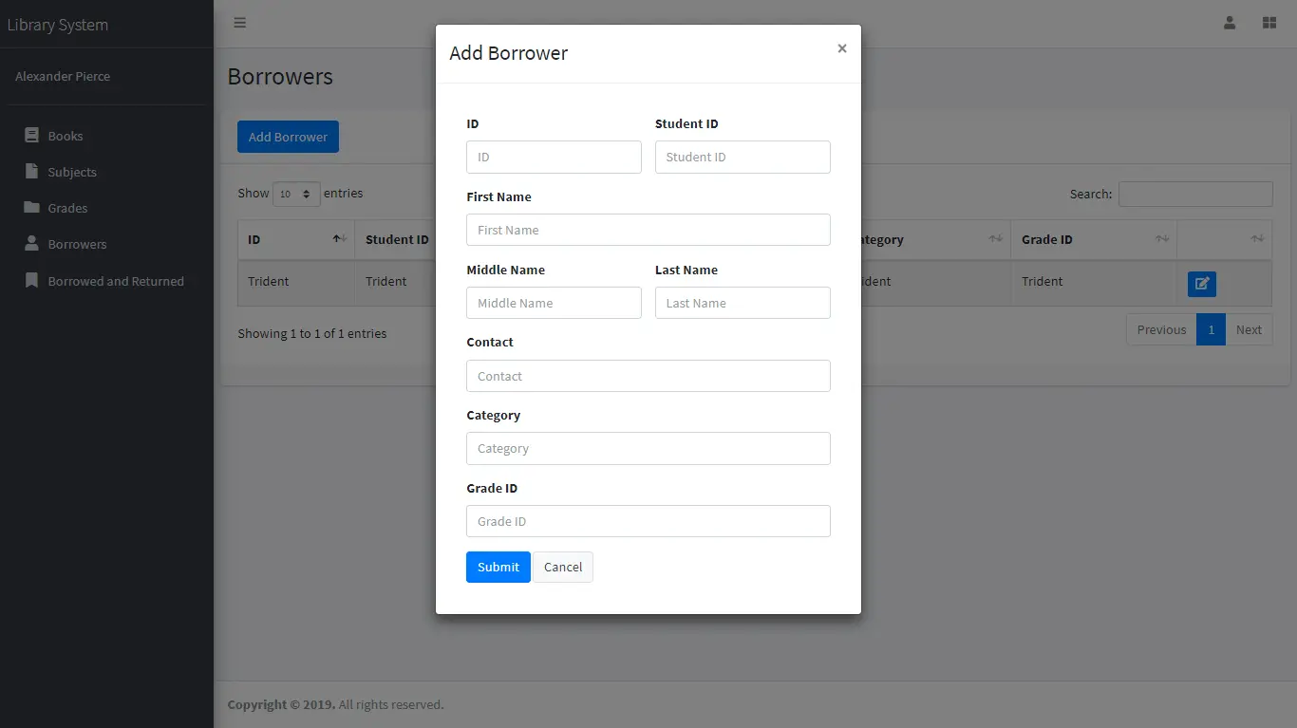

Figure 8.3 Screen-3: Add borrower book

**Purpose** This module will allow the system administrator to add, edit, update or delete borrowers of book. The admin can add borrower information and manage it.

Table 8.3 Screen element of Add borrower book

|  |  |  |
| --- | --- | --- |
| Sr. | Field Name | Description |
| 1 | Borrower ID | Borrower ID field should be editable and fill autogenerated Borrower ID. |
| 2 | Student ID | Student ID field should be editable and accept Student barcode id. |
| 3 | First Name | First Name field should be editable and accept only string as a borrower first name. |
| 4 | Middle Name | Middle Name field should be editable and accept only string as a borrower middle name. |
| 5 | Last Name | Last Name field should be editable and accept only string as a borrower last name. |
| 6 | Contact | Contact field should be editable and accept only 10-digit mobile number. |
| 8 | Submit | Submit is a button for store the entered data into database. |
| 9 | Cancel | Cancel is a button for close add borrower dialog. |

Practical 9

Prepare database schema and ER diagram of the given project.

### List of Tables

1. Book
2. Borrower
3. Student
4. Staff

#### Table Name: Book

Table 9.1 Table: Book

|  |  |  |  |  |
| --- | --- | --- | --- | --- |
| Column | Data Type | Null | Keys & Constrains | Default Value & Description |
| BookID | int | NN | PK (Auto Increment) |  |
| BookName | varchar(100) | NN |  |  |
| ISBN | varchar(100) | AN |  |  |
| Publication_year | int | AN |  |  |
| Language | varchar(50) | AN |  |  |

#### Table Name: Borrower

Table 9.2 Table: Borrower

|  |  |  |  |  |
| --- | --- | --- | --- | --- |
| Column | Data Type | Null | Keys & Constrains | Default Value & Description |
| BorrowerID | int | NN | PK (Auto Increment) |  |
| BookID | varchar(100) | NN | FK | Reference of Book Table |
| BorrowedFromDate | DateTime | AN |  |  |
| BorrowedToDate | DateTime | AN |  |  |
| ActualReturnDate | DateTime | AN |  |  |
| IssuedBy | int | NN | FK | Reference of Student and Staff Table |

#### Table Name: Staff

Table 9.3 Table: staff

|  |  |  |  |  |
| --- | --- | --- | --- | --- |
| Column | Data Type | Null | Keys & Constrains | Default Value & Description |
| StaffID | int | NN | PK (Auto Increment) |  |
| StaffName | varchar(100) | AN |  |  |
| IsAdmin | Boolean | AN |  |  |
| Designation | varchar(100) | AN |  |  |

#### Table Name: Student

Table 9.4 Table: Student

|  |  |  |  |  |
| --- | --- | --- | --- | --- |
| Column | Data Type | Null | Keys & Constrains | Default Value & Description |
| StudentID | int | NN | PK (Auto Increment) |  |
| StudentName | varchar(100) | AN |  |  |
| Gender | varchar(100) | AN |  |  |
| DOB | DateTime | AN |  |  |
| Department | varchar(100) | AN |  |  |
| Contact | number(10,0) | AN |  |  |